**SMART BRIDGE**

**Let’s Bridge the gap**

**Summer Internship Report** **IISPS-INT-2125-Predicting-Life-Expectancyusing-Machine-Learning**

**Submitted By**

**Tharun Murugaiyan**

**Preface**

Life expectancy is a statistical measure of the average time a human being is expected to live, and depends on various factors: Regional variations, Economic Circumstances, Sex Differences, Mental Illnesses, Physical Illnesses, Education, Year of their birth and other demographic factors. This problem statement provides a way to predicting average life expectancy of people living in a country when various factors such as year, GDP, education, alcohol intake of people in the country, expenditure on healthcare system and some specific disease related deaths that happened in the country are given.

# 

# Index

## 1) INTRODUCTION

1.1 Overview

1.2 Purpose

## 2) LITERATURE SURVEY

2.1 Existing problem

2.2 Proposed solution

## 3) THEORITICAL ANALYSIS

3.1 Block diagram

3.2 Hardware / Software designing

**4) EXPERIMENTAL INVESTIGATIONS**

**5) FLOWCHART**

**6) RESULT**

**7) APPLICATIONS**

**8) CONCLUSION `**

**9) BIBILOGRAPHY**

**10) APPENDIX**

A. Source code

## 1. Introduction

**Problem Statement-** Predicting Life Expectancy Using Machine Learning

**Problem Description :**

A typical Regression Machine Learning project leverages historical data to predict insights into the future. This problem statement is aimed at predicting Life Expectancy rate of a country given various features.

Life expectancy is a statistical measure of the average time a human being is expected to live, Life expectancy depends on various factors: Regional variations, Economic Circumstances, Sex Differences, Mental Illnesses, Physical Illnesses, Education, Year of their birth and other demographic factors. This problem statement provides a way to predict average life expectancy of people living in a country when various factors such as year, GDP, education, alcohol intake of people in the country, expenditure on healthcare system and some specific disease related deaths that happened in the country are given.

**Purpose**

Built a machine learning model for the prediction of life expectancy.

Life expectancy is a statistical measure and predicting life expectancy helps to determine the course of treatment, managing health care services and facilities, help in planning, managing resources, care planning improves the quality of the final phase of life by simulating doctors to explore the preference for end of life.

1. **LITERATURE REVIEW:**

**Predicting** the **lifespan** of people, or their “Personal **Life Expectancy**” (PLE) would greatly alter our lives. On one hand, it may have benefits for policy making, and help optimize an individual's health, or the services they receive.

* 1. **Existing Solution:** 
     + In our regular system, there are some problem arise because whole concepts depends upon morbidity and mortality like smoking, alcohol, consumption, overweight and others health issues.
     + From previous researches, we take a data-set from 2000-2015 and applied regression techniques.

* 1. **Proposed Solution:**

For our problem we have a dataset of different country consist of various factors, some important factors such as HIV, Hepatitis B, Polio, Diphtheria are considered.

The data set we considered related to health factor of 193 countries and has been collected from WHO data repository.

In our project we use some immunization factors, morality factors, economic and social factors to predict life expectancy using Machine learning model.

## 3. THEORITICAL ANALYSIS

### 3.1 Block diagram

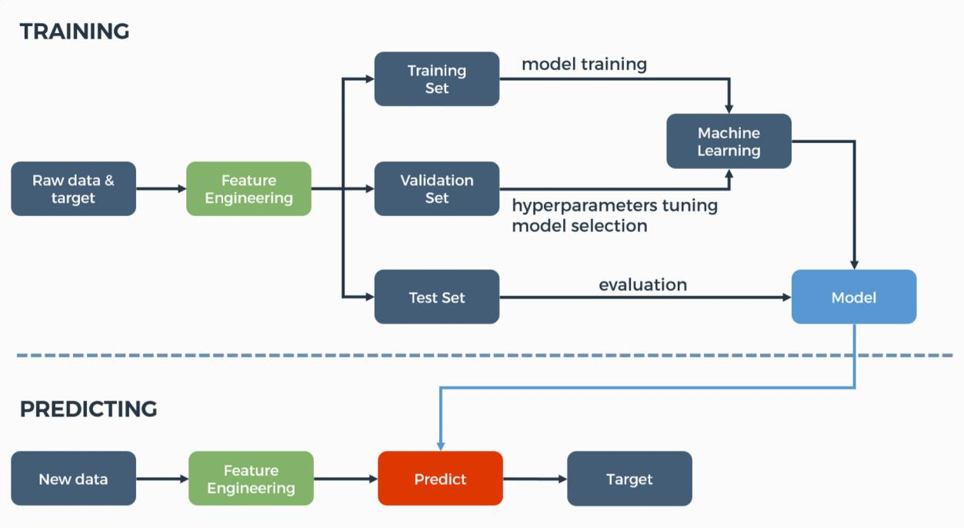

**3.2 Hardware and Software Requirement:**

1. Project Requirement: Python, IBM cloud, IBM Watson
2. Functional Requirement: IBM cloud
3. Technical Requirement: ML Watson Studio, Node-Red
4. Software Requirement: Watson Studio, Node-Red

**4. EXPERIMENTAL INVESTIGATIONS**

**A).Choose a project idea:**

a. Predicting life expectancy of a Country

**B). Conducting a background research**

Dataset: https://www.kaggle.com/kumarajarshi/life-expectancy-who **C). Some important Factors Which I have used are:** I. Adult Morality

1. Infant deaths
2. Alcohol
3. Percentage Expenditure V. Hepatitis B
4. Measles
5. BMI
6. Under five deaths IX. Polio
7. Total expenditure
8. Diphtheria
9. HIV/AIDS
10. GDP
11. Populations
12. Thinness 10-19 years
13. Thinness 5-9 years
14. Income Expenditure
15. Schooling

**D). Finding most suitable algorithm: Linear Regression** gives me the highest accuracy of 82% .

**E). Steps:**

1). Create IBM Cloud Services

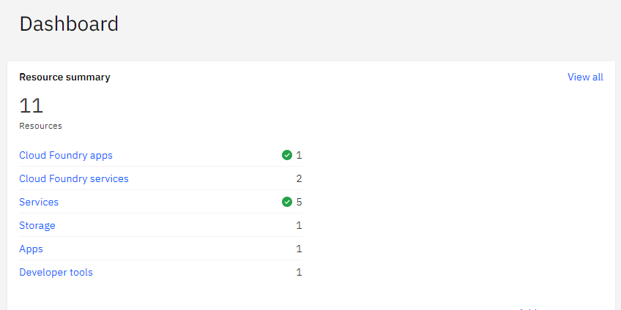

2). Resources List

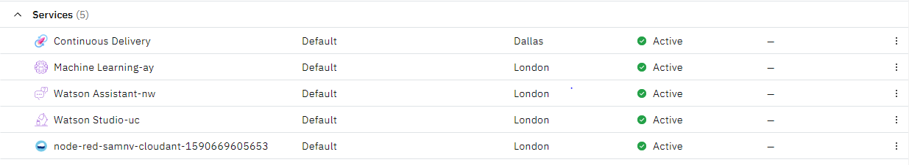

3) Watson Machine Learning Service:



4). Watson Studio:



5) Watson Notebook

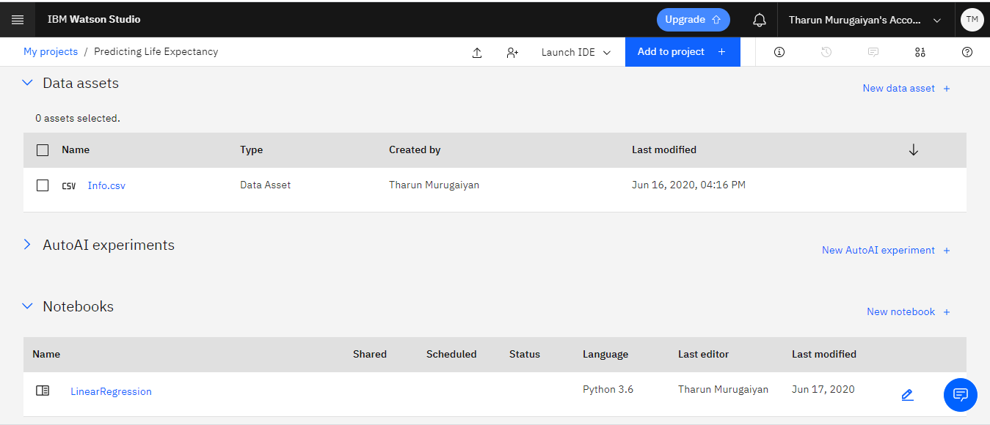

6). Watson Model

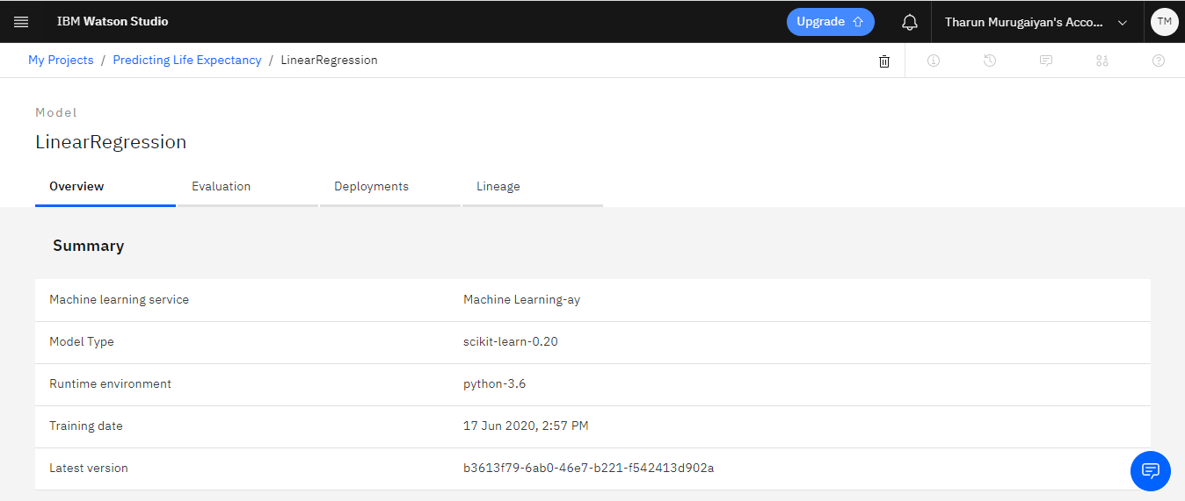

7) Notebook:

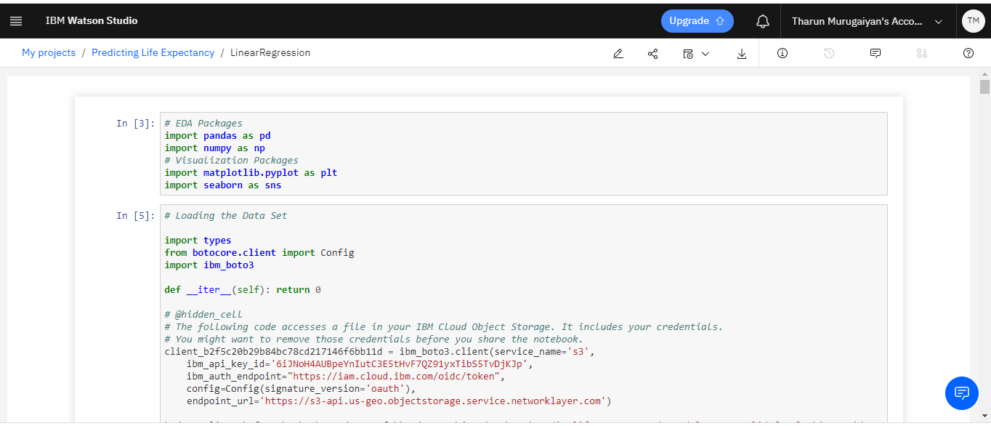

8). Node Red Flow:

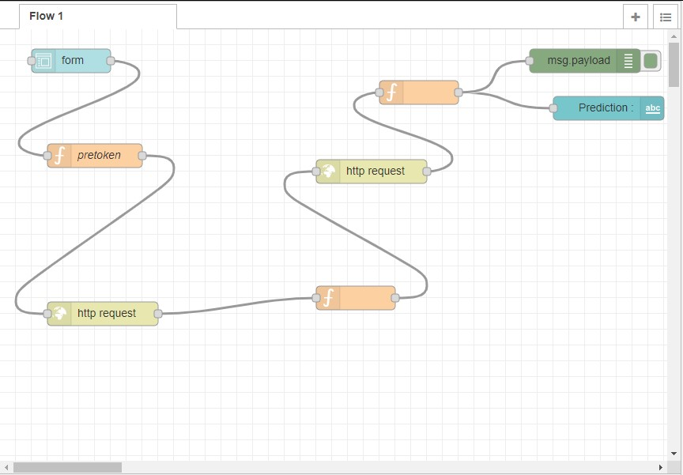

9) Node Red UI:

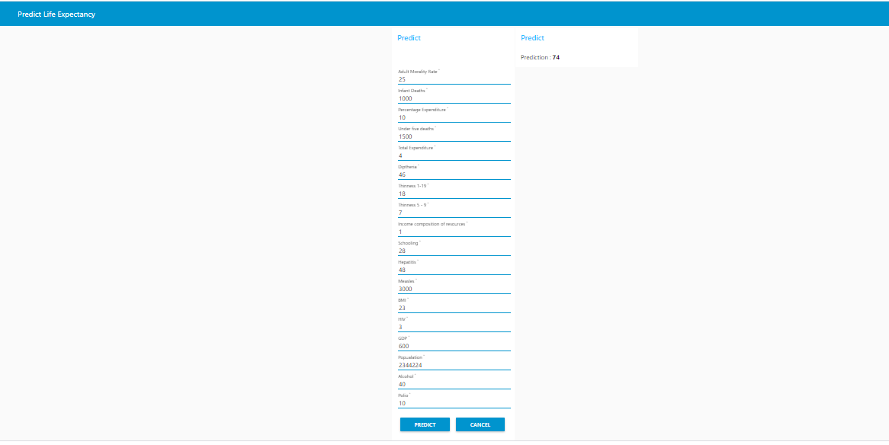

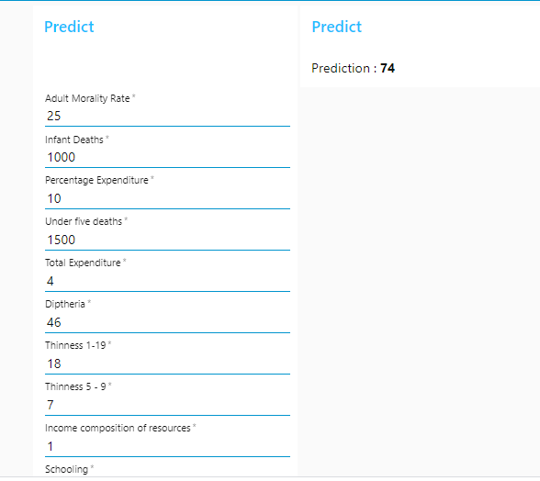

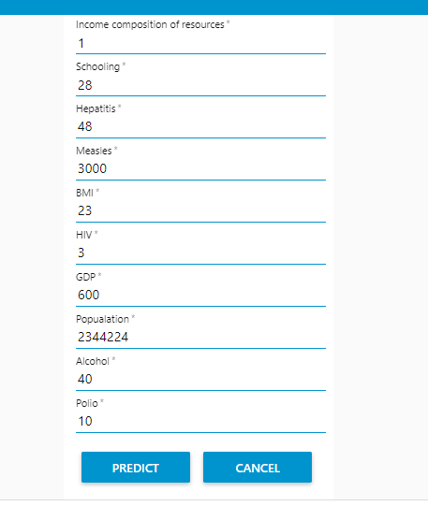

## 5. FLOWCHART

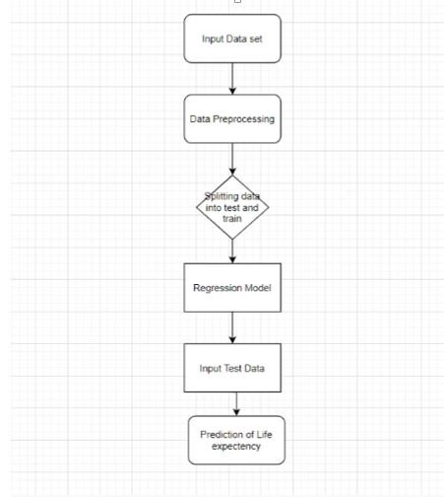

## 6. RESULT

**Prediction** of life expectancy based on adult molarity, GDP and population etc.

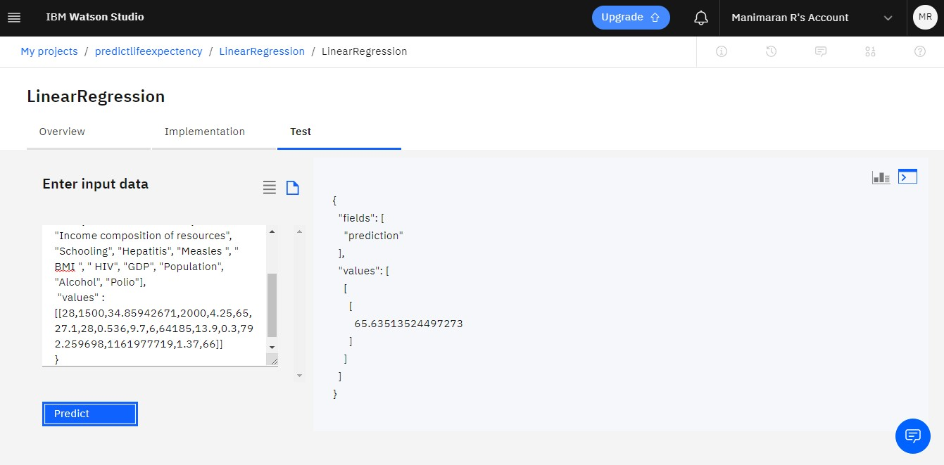

## 

## 7. ADVANTAGES & DISADVANTAGES

**7.1 Advantages:**

* User friendly Interface: This interface is very attractive, no background knowledge requires, it is simple web UI and ask for required input and predict output.
* Reduced costs: This simply a web page and does not required any kind of payment neither for designing nor for using.
* Can be used in any organization to analyze the data
* Regression technique is comparatively less impacted by noise.
* The dataset are available to public for the purpose of health data analysis.

**7.2 Disadvantages:**

* Can be only used by the people having the knowledge of data analysis.
* As the model is deployed on Cloud, so one requires good internet connections to use the applications.
* The model predicts averages or approximates value with 82 % accuracy.

## 8. APPLICATIONS

* It can be used to monitor health inequalities of acountry.
* It can be used to develop statistics for country development process.
* It can be used to analyse the factors for high life expectancy.
* It is user friendly and can be used by anyone.

## 9. Conclusion

Some interesting correlations here:

* There is a strong positive correlation between ‘Schooling’ and ‘Life Expectancy’. This may be because education is more established and prevalent in wealthier countries. This means countries with less corruption, infrastructure, healthcare, welfare, and so forth.
* Similarly to the point above, there is a moderate positive correlation between ‘GDP’ and ‘Life Expectancy’, most likely due to the same reason.
* Surprisingly there’s a moderate positive correlation between ‘Alcohol’ and ‘Life Expectancy’. I’m guessing that this is due to the fact that only wealthier countries can afford alcohol or the consumption of alcohol is more prevalent among wealthier populations.

## 10. BIBLIOGRAPHY

○ **https://cloud.ibm.com/login** ○ **https://developer.ibm.com/tutorials/how-to-create-a-node-red-starterapplication/** ○ **https://nodered.org/** ○ **https://www.ibm.com/watson/products-services** ○ **https://developer.ibm.com/technologies/machine-learning/series/learning-pathmachine-learning-for-developers/** ○ **https://developer.ibm.com/technologies/machine-learning/series/learning-pathmachine-learning-for-developers/** ○ **https://developer.ibm.com/tutorials/watson-studio-auto-ai/** ○ **https://www.kaggle.com/kumarajarshi/life-expectancy-who** ○ **https://bookdown.org/caoying4work/watsonstudio-workshop/jn.html#deploymodel-as-web-service**

## 11. APPENDIX

GitHub Link: <https://github.com/SmartPracticeschool/llSPS-INT-2125-Predicting-Life-Expectancy-using-Machine-Learning>